**Hand Gesture Recognition**

*Aashish Pandey Anjan Shrestha Nitin Dunday Mohan Asher Pranay*

**GitHub Link : https://github.com/anjanshrestha123/hand-gesture-recognition**

# Idea Description **:** The Main idea is to detect the gesture from the image containing hands by using image processing techniques and Machine Learning Classifier. Initially, we detect the hand in an image by using foreground detection then the image gesture is detected. If we are unable to detect the hand in the image it returns output as no gesture is recognised.

# We will utilize the dataset available in kaggle[1] to train and validate the model. The dataset consists of 10 different hand gestures from 10 different people. The total number of images present in the dataset is 20,000. The dataset is publicly available and already downloaded in our local machine.

# Goals **:** We have two specific goals for this project. First, we will generate/extract the features in the image with respect to the gesture presented in the image. Secondly, we will create the machine learning classifier which will utilize the learned representations to classify the image into its respective labels.

# Motivation **:** With the evolution of Convolution Neural Networks, the task of image processing/detection has been more simple and effective. The deep learning techniques implicitly learns the image features and create an end to end model for image classification. However, in this project we are extracting the various image features explicitly using image processing tools and using those features to classify the images. We would like to compare the results of our model with CNN model to understand the difference between the two techniques.

# Significance **:** The task of gesture recognition has very high significance. It can be used to provide the input to smart devices . One of the most important applications of gesture recognition include sign language translation. Furthermore, gesture recognition has important applications on warning road hazards, creating music, robot remote control etc.

# Literature Survey**:** As hand gesture recognition is very important for human and computer interaction, many researches have been performed in this area. [2] proposed a technique which has six static and eight dynamic hand gestures with 93.09% accuracy. They have used VGG16 pretrained model which is a type of CNN based classifier that consists of 13 convolution layers and 3 fully connected layers.

# [3] has provided some glimpse of Deep Learning feature extraction techniques. In these techniques, traditional feature extraction has been replaced by convolution neural networks (CNN) as it has the ability to extract complex features present in the image. Multiple works have been performed on this techniques such as SuperPoint which is a Self-Supervised Interest Point Detection and Description, D2-Net which is a Trainable CNN for Joint Description and Detection of Local Features, LF-Net which is a Learning Local Features from Images, Image Feature Matching Based on Deep Learning and Deep Graphical Feature Learning for the Feature Matching Problem.

# [4] performed research on the significance of hand gesture recognition in vehicular automation. They have described two approaches used in gesture detection systems. One of the approaches is accelerometer based approach which works on 18 gestures over 3700 traces from different subjects, and the system achieved almost perfect recognition for user dependent recognition, mixed user and user independent recognition etc. Another approach is glove based approach which consists of active data glove based detection method and passive data glove based method.

# Similarly, [5] proposed a system that performs hand gesture recognition with skin detection using deep learning methods. In this system, skin color is detected first and then features are extracted using contour extraction and hand region segmentation and gesture is detected using the pyramidal pooling module and attention mechanism.

# Objective**:** The Main objectives of the project is done by the milestones such as 1. Data collection (Collection the information from the Kaggle data set) 2. Preprocessing Data (Removing all the outliers and getting the features to process the model) 3. Data Model (Apply Machine Learning Model: Feature Engineering like Sharpening the image, using linear and horizontal gradients) 4. Evaluate the Model (Processing the Model information and evaluating using test and train data.) 5. Final prediction (Final Output is predicted and displayed to the user).

# Features: Extracting distinct/unique features from the image is the most important step for classification of the images. The images in the same class must have similar features, and the images in the different class must have different features. In order to extract those specific features from our dataset points, we are planning to apply following steps for feature generation:

1. **Foreground Enhancement:** Our training and testing images consist of a hand gesture with some background. Our first step will be to enhance hand image (or background subtraction) such that the features will be generated for hand gestures rather than background noise.

# 

*Fig: Original Image Fig: Gesture enhanced*

1. **Keypoint Detection:** In this step. We will generate several key points in the gesture enhanced image using ORB detector and use the key points as one of the features of the image. In the picture below, we can see the key points in the palm image are distributed differently from key points in the index image. Hence we can use this information to distinct one image from other

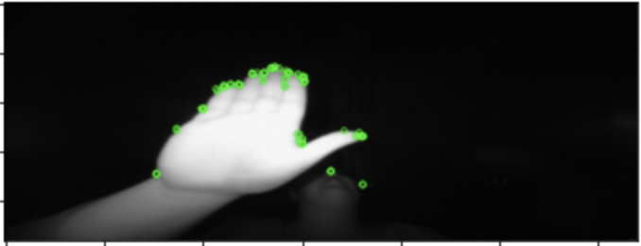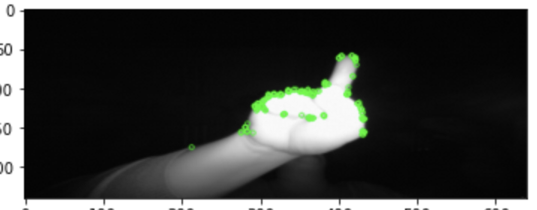  
*Fig: Distribution of Key Points in palm Fig: Distribution of Keypoints in Index*

1. **Edge Detection**: We are planning to use the edge information of an image as a feature. The vertical/horizontal edges and their relative position in each gesture are different from each other. Hence, this information will also help us(our classification model) distinguish between the gestures. In order to generate distinct edges, we are planning to use image sharpening in gesture enhanced images.
2. Furthermore, we will try several other feature detection techniques presented in [6] in order to extract the comprehensive features. We will not be using any features related to color as our dataset consists of grayscale images.

In this way, we will generate distinct features from gesture images and feed these features to our classification model for the prediction.

# Expected Outcome: The classification accuracy of the implementation by [7] is almost perfect ie. 99.98%. Hence, it is technically impossible to outperform their result. However, we expect to generate the result with fairly high confidence i.e. > 95% accuracy. Also, we expect our model to successfully classify the external hand gesture (the pictures of our hand gesture.

# References:

1. [**https://www.kaggle.com/benenharrington/hand-gesture-recognition-database-with-cnn/data**](https://www.kaggle.com/benenharrington/hand-gesture-recognition-database-with-cnn/data)
2. [**https://ieeexplore.ieee.org/stamp/stamp.jsp?tp=&arnumber=8368821&tag=1**](https://ieeexplore.ieee.org/stamp/stamp.jsp?tp=&arnumber=8368821&tag=1)
3. [**https://towardsdatascience.com/image-feature-extraction-traditional-and-deep-learning-techniques-ccc059195d04**](https://towardsdatascience.com/image-feature-extraction-traditional-and-deep-learning-techniques-ccc059195d04)
4. [**https://citeseerx.ist.psu.edu/viewdoc/download?doi=10.1.1.678.7152&rep=rep1&type=pdf**](https://citeseerx.ist.psu.edu/viewdoc/download?doi=10.1.1.678.7152&rep=rep1&type=pdf)
5. [**https://iopscience.iop.org/article/10.1088/1742-6596/1213/2/022001/pdf**](https://iopscience.iop.org/article/10.1088/1742-6596/1213/2/022001/pdf)
6. [**https://towardsdatascience.com/image-feature-extraction-traditional-and-deep-learning-techniques-ccc059195d04**](https://towardsdatascience.com/image-feature-extraction-traditional-and-deep-learning-techniques-ccc059195d04)
7. [**https://towardsdatascience.com/tutorial-using-deep-learning-and-cnns-to-make-a-hand-gesture-recognition-model-371770b63a51**](https://towardsdatascience.com/tutorial-using-deep-learning-and-cnns-to-make-a-hand-gesture-recognition-model-371770b63a51)